CITY OF SYDNEY BASKETBALL ASSOCIATION

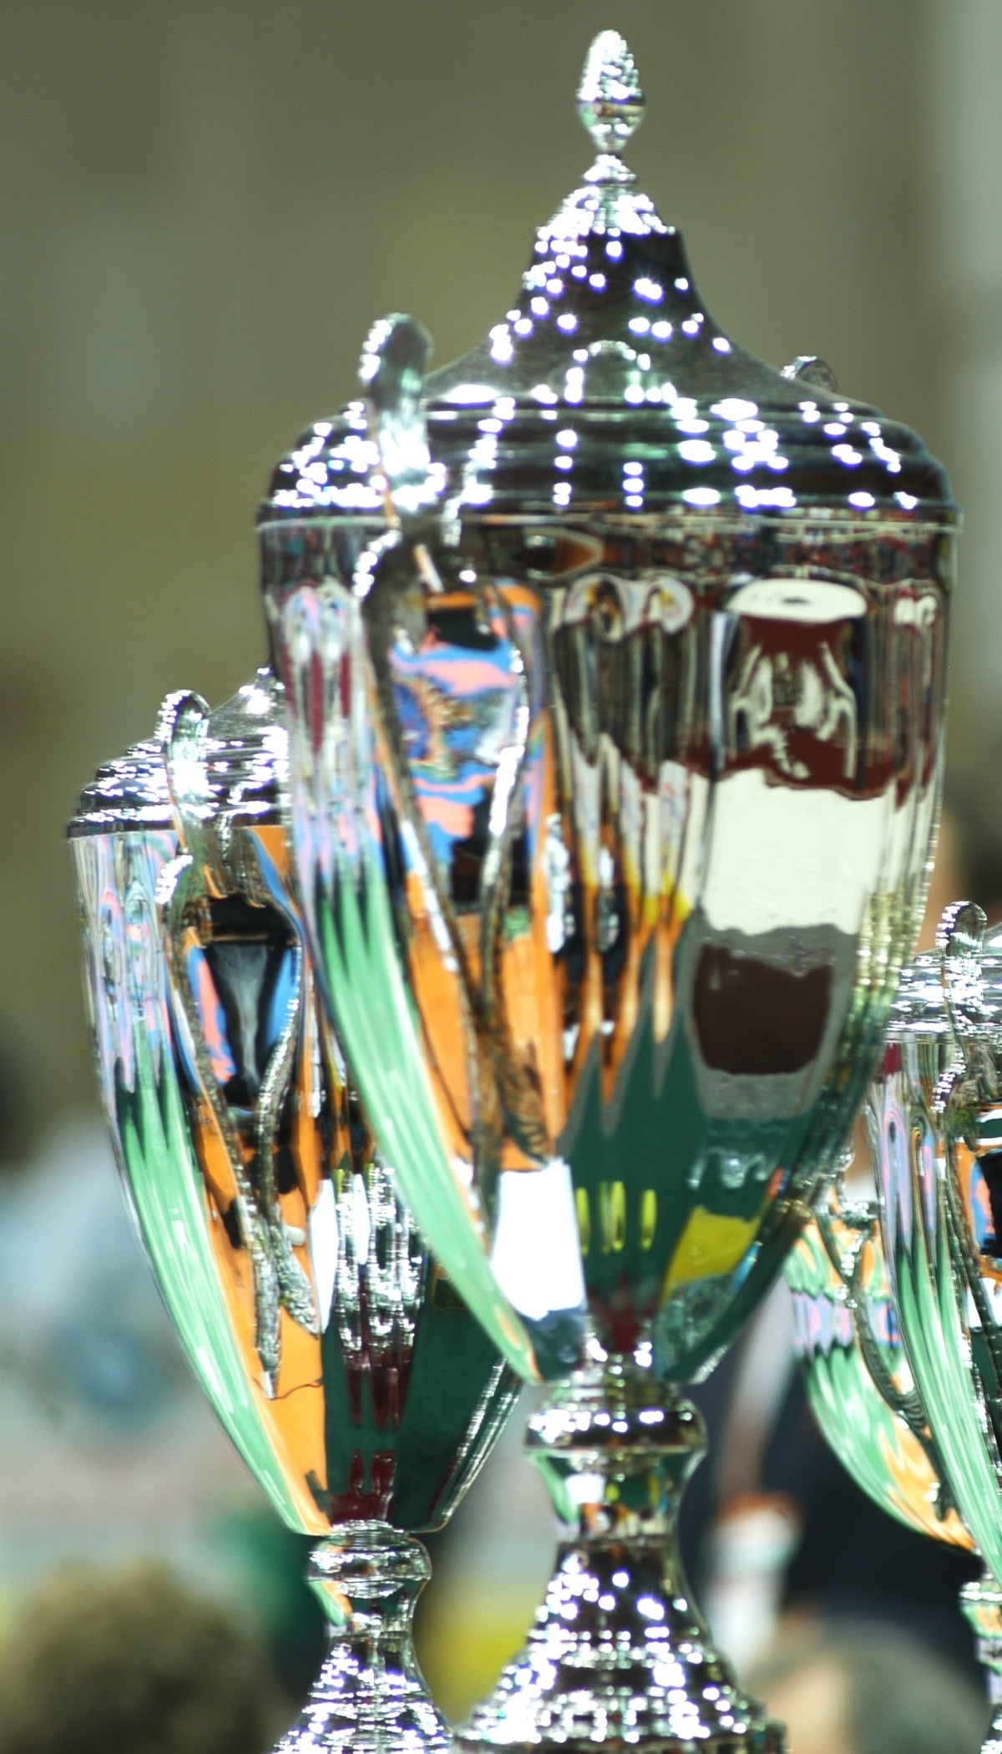
Under 12’s

Division | CHAMPION | RUNNER-UP
U12 Girls Elite | Pocket Rockets | The Noodles
U12 Boys Elite | Hardwood Ninjas | The AirBallers
U12/14 Boys Social | LEJs | Inner City Warriors

Under 14’s

Division | CHAMPION | RUNNER-UP
U14 Girls Elite | The Heat | Pocket Rockets
U14 Boys Elite | Go Sniffy
Under 16’s

Division | CHAMPION | RUNNER-UP
U16 Girls Elite | Prodigious | Opals
U16/18 Boys Elite | TeinaTokoUso | Wolfpack
U16 Boys Social | Swoosh | Zoom

